**Lab 3**

1. Adjust the histogram of the following image to match the reference image using histogram matching. Show the histogram of original, reference, and output images.

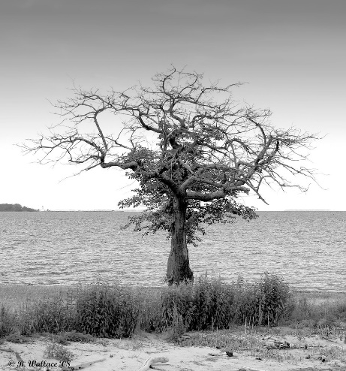 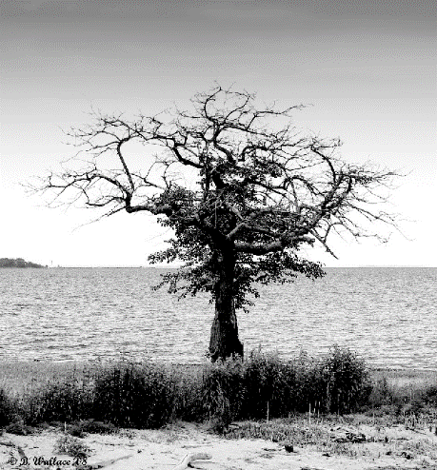

1. Change the contrast of the image using histogram equalization. Show the histogram of both input and output images.

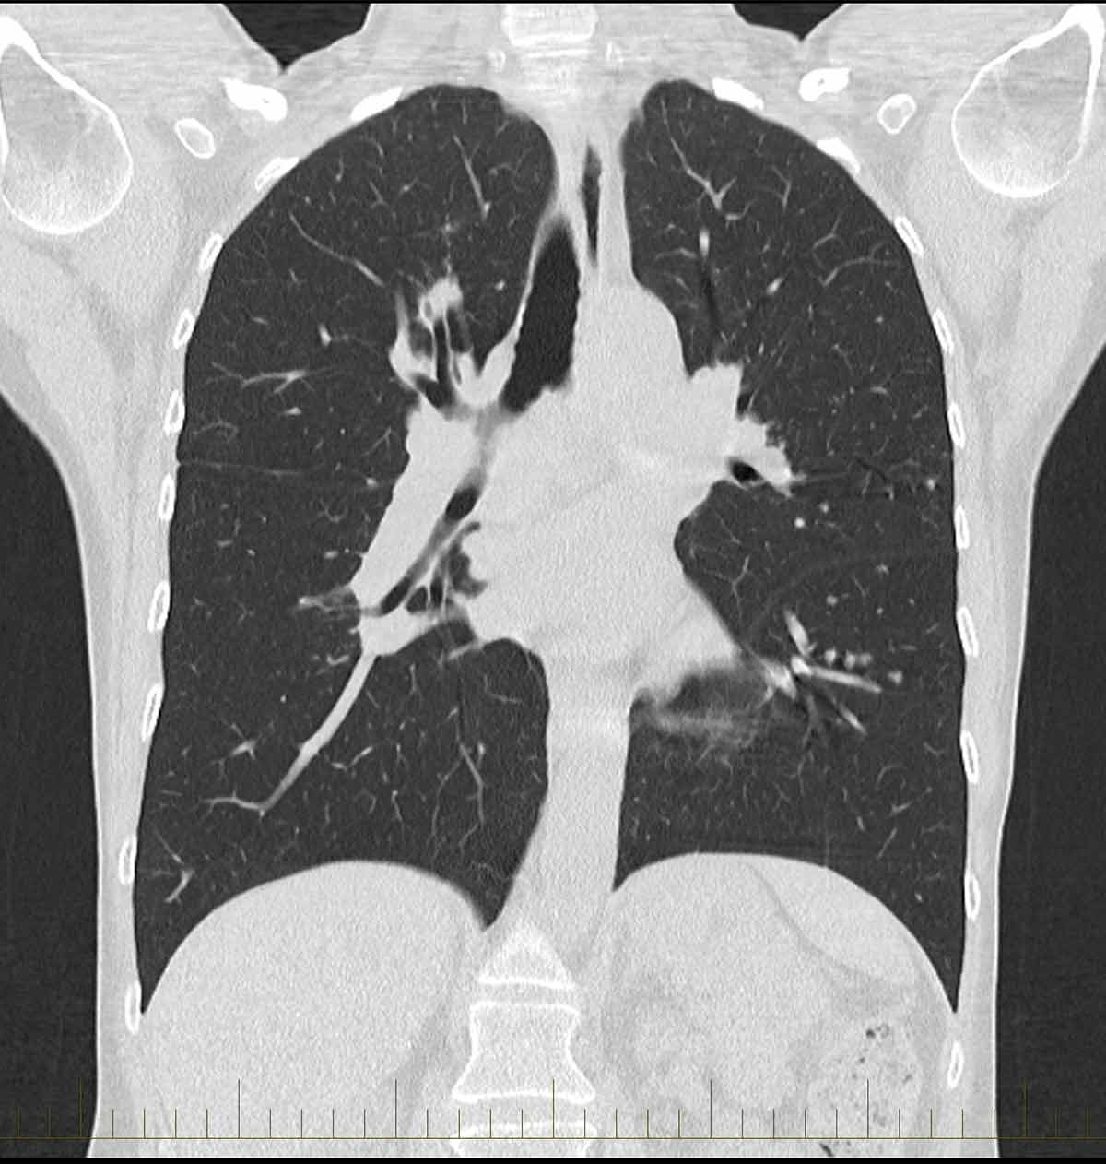

1. Apply salt and pepper noise to the following image and remove the noise using min and max filtering technique. Show input and output side by side.

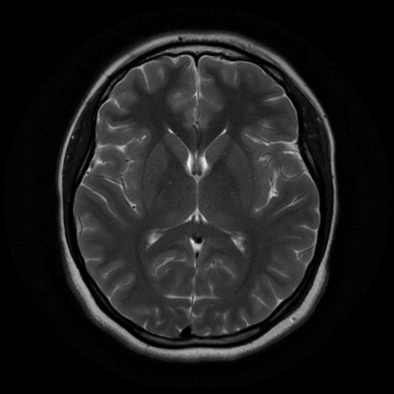

1. Apply Gaussian noise to the following image and remove the noise using Gaussian filtering. Show input and output side by side.

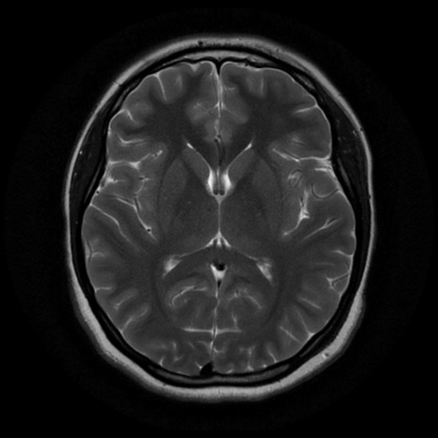

1. Apply any noise to the following image and restore it using:
2. Box filtering
3. Average filtering
4. Median filtering

Show input and output side by side. Also show the comparison between the 3 techniques. Mention which method works better than others.

